Family Meditation: The Art of Abiding Peacefully Together
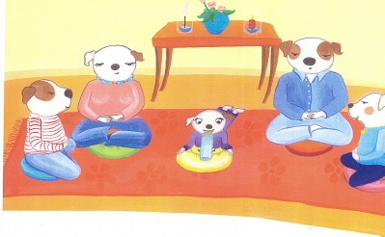
As parents we teach our children to care for their bodies by brushing their teeth, eating right and getting enough sleep, but we aren’t quite as clear when it comes to teaching them how to maintain their mental health. Extensive research confirms that just a few minutes of sitting meditation each day calms the mind, body and spirit. When family members have a peaceful place inside themselves, they naturally become happier and more positive, getting along better with each other and those in their world. For both children and adults, everyday obstacles become more workable and natural harmony is easily regained. This article presents some guidelines for developing a family meditation practice.
Before Meditation
You can set the mood for family meditation sessions by bringing in a nice cup of tea or hot chocolate for everyone to enjoy in the meditation area together after your mini-meditation, when everyone’s feeling peaceful, present and more available to actually connect with each other, and before you all have to dash off in ten different directions! You may just sit in a companionable silence, or chat about your plans for the day, or how your day went; whether silent or chatty, these post meditation moments are rich with connection, which ultimately lays the ground for the open communication that fuels family harmony. Just being together for a few minutes brings the family intimacy children deeply need, and will turn your daily sessions into something warm and wonderful that everyone looks forward to.
Yoga
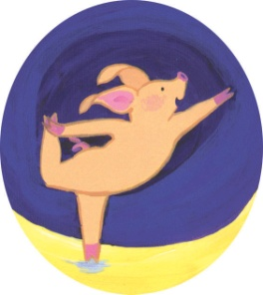
If there’s time, yoga stretches are a pleasant way to relax and energize both body and mind before meditation. It’s also a great way to get riled-up kids to calm down a bit before you try sitting meditation. The ‘Eagle’ posture is great for stretching between the shoulder blades where it gets tight during sitting, the ‘Triangle’ is good for stretching your sides, and ‘Lord of the Dance’ (shown right) opens hip joints and stretches leg muscles.
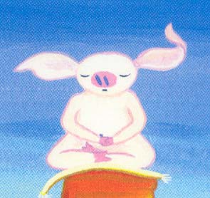

THE MEDITATION SESSION
Family Meditation in a Nutshell
- Sit on cushions in a special, sacred space.
- Children can take turns ringing the gong and helping to light candles and incense.
- In a playful manner, remind everyone we’re meditating to clean our own mind, so it doesn’t get grimy and grumpy, or anxious, or… whatever words fit their person best. Gently encourage good posture, but don’t push it..
- Sit for 1 to 5 minutes, depending on ages and abilities.
- Gently remind everyone to feel their breath going in and out (ages 8+ only).
- Younger children can be very gently encouraged to simply be quiet and still.
- Don’t worry if children are restless, they’ll settle down slowly, over weeks, months and years. Patience.
- Allow the children to take turns ringing the gong to end.
- Get kids into the habit of waiting until they can’t hear the sound of the gong anymore before moving and talking again.
- Whenever possible, follow with special time together, reading, talking about your day, or enjoying a companionable cup of tea or hot chocolate.
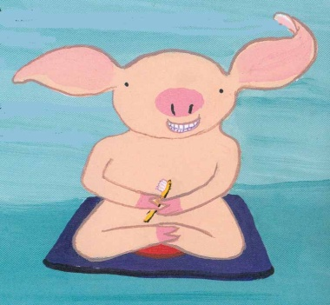

Before each session, I used to tell my children, “We have to brush our teeth to keep them clean, so our breath doesn’t stink and our teeth don’t fall out. And, we have to sit to keep our minds clean; otherwise we get grumpy and unhappy and no one wants to be with us.”

Getting Started
To help create a peaceful ambiance, you might want to let your children take turns lighting a candle, representing clear thinking, and incense, representing patience. Lighting incense and candles brings a sense of ritual to the whole thing, (I’ve found that children love the safe and happy feeling of daily sacred rituals). And, if they ask why you’re lighting candles and incense you can explain, (to older children) that the candle is to remind you that meditation clears your mind so you can think clearly, so you’ll do better at school, doing homework, or even just playing games; and the incense is to remind you to be patient while you’re sitting there.
Everyone could sit in a semi-circle in the sacred space you’ve set up. Even toddlers and children under age 8 should have their very own cushion and just try to sit quietly — that in itself is a huge accomplishment! A little squirming and bouncing is allowed. And, being less conceptual creatures who are already very much in the present moment, they will naturally soak up the peace in the atmosphere. Just encouraging children to be comfortable with stillness and silence for even a few seconds at a time will start the process of growing a peaceful place inside, and that peaceful place gives them a connection to their own inner wisdom as they mature.
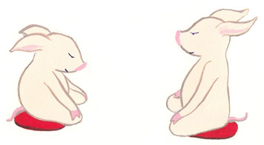
Posture and Meditation Instruction
Using humor and a light touch at all times, gently help children to sit on their pillow like Buddha: cross-legged, with their back straight but not rigid. Having good posture is important for creating a happy state of mind. For contrast, have everyone slouch heavily. Have older kids take notice of how restricted breathing and a slumped torso can actually make them feel heavy and depressed. Now take your posture again, with good head and shoulders.
You can tell older children something along the lines of: “Gaze softly down at the ground about six feet ahead (for adults) and two or three feet ahead (for children). Your eyes are open but relaxed, so that you can remain fully present in the here and now. Keep your gaze unfocused. Take your seat with the regal posture of a king or queen. Feel the strength of the solid earth beneath you, the vastness of the big sky above you, and your own heart, body and mind bridging them together, joining heaven and earth.”
Ring the Gong to Start
Have kids ring the gong once to begin your meditation session. Place the striker on the floor, and listen to the sound reverberate out. Sitting upright, quiet and still for 30 seconds at a time, is enough for younger children to settle their minds and begin cultivating a quiet and still place inside.

Ring the Gong to End
Ring the gong once to end, encouraging everyone to stay quiet and still until the sound has completely dissipated. Rest in the peaceful moment you’ve created.
Probably the most important thing to remember is to keep things light and playful; and never let the atmosphere be tainted with aggression, impatience or a heavy, somber attitude.
Now your minds are relaxed and clear, so you can appreciate your world together!
Take a moment to enjoy your coffee, tea or hot chocolate together before everyone has to get going and the speed slowly begins to build all over again! If there’s time, a post-meditation stroll can be delightful. Looking back over the years, these post-meditation moments were some of the most intimate and sweet times my husband and I have shared with our children. Perhaps that’s the best reason of all to hang in there with family meditation, despite all the obstacles!
The following instructions are for teenagers and adults.
When we first sit down, it’s a good idea to just settle in for a minute, before we begin practicing the technique. It helps to take the time to feel who we are at that particular moment in time.
The natural speed with which we operate is such that when we first stop,we spin around and around in our thoughts – very much like Wile E. Coyote in the Roadrunner cartoons. He runs so fast his head goes b-o-o-i-i-ng-ng-ng,back and forth for several seconds after he stops. That’s us when we first sit down. B-o-o-i-i-ng-ng-ng.
So we need to take the time to settle down and become present with ourselves and see who we are at that particular moment. Maybe we’re in a rotten mood, maybe we’re depressed. Maybe we’re in an exceptionally good mood, or we might be scattered, running around in circles of thought. Or, we could be feeling nothing — just flat. It doesn’t matter, we just need to take stock and acknowledge our state of mind as we begin. This allows us to have some idea of what to work toward in our session.
If we’re tired and grumpy, we shouldn’t expect to have perfect form and discipline in working with our thoughts, which may be fuzzier than usual. But if we got enough rest, had an excellent breakfast and the sun is shining that day, we might be able to go further and deeper with our meditation.
State Your Plan
It’s important to begin with a clearly-stated plan, so that we don’t end up spacing out the whole five or ten minutes, wandering in our thoughts. We can say to ourselves something like, “Just for the next few minutes I’m going to train my mind to my breath. The other 1,425 minutes in my day I can follow my thoughts on any interesting, exciting, happy, stressed out or horrifying trail they want to wander along. But for just this short time I’m going to let go of my thoughts and be fully present here in this room with my breath.”
How Long Should We Meditate?
Sitting for one minute is perfect for young children and toddlers. Five minutes is good for a mature daily family practice, and if you can stick with that you’ll be very happy with the results. On weekends when you have more time and if your children are older, it might be nice to sit for ten minutes. The longer you sit, the more settled you all become.
Once you’ve become comfortable with sitting meditation, you can figure out what works best for you. It’s a very personal thing.
Following the Breath
It’s the nature of mind to flow on and on like a river, with one thought following another, just as one breath follows another. We are not out to stop that flow. We simply want to gently bring our attention away from our thoughts of the past and the future, the this and the that, directly into the fresh and spacious present moment. Therefore, the breath — which joins our spirit and body, which is alive, always fresh and happening right here, right now — is the perfect place to put our attention.
We gently bring our attention to our natural breathing rhythm. We feel the air going in and out of our nose, our chest rising and falling. We pay more attention to the out-breath than the in-breath. We just go out with the expansive quality of our out-breath and, ahhhh… let go of our thoughts. Then we rest our mind in that space for a moment before breathing back in.
“Good and bad, happy and sad, all thoughts vanish into emptiness like the imprint of a bird in the sky.”
Building the ‘Letting Go’ Muscle
As my meditation teacher, Sakyong Mipham, says in his book Ruling Your World, trying to let go of your thoughts over and over again, is a bit like bringing your meandering horse back to the trail every time he wanders off. You have to be gentle about it, but determined, too.
If you try too hard to pay attention to your breath, your mind will take off into a maze of intense thoughts and emotions. It may be minutes before you’re consciously present on the cushion again. Yet, if you relax too much, you’ll end up wandering off or even falling asleep. The best approach is ‘not too tight, not too loose.’ Every time you notice you’re thinking, just gently bring your attention back to the breath, again and again.
It’s important not to judge your thoughts. They are not inherently good or bad — in the end, they’re just thoughts. You don’t necessarily act on them. They’re just thoughts. Let them go. As soon as you realize, “oh, I’m thinking …” — whether you’re replaying an upsetting conversation, remembering what happened at work yesterday, planning what needs to be done tomorrow, or thinking about anything from dinner to global warming to world peace — whatever it is, you can gently acknowledge that it’s just a thought, not nearly as weighty as it may seem. Just let it go, whatever it is, and bring your attention back to the present.
Now your minds are relaxed and clear, so you can appreciate your world together!
Take a moment to enjoy your coffee, tea or hot chocolate together before everyone has to get going and the speed slowly begins to build all over again! If there’s time, a post-meditation stroll can be delightful. Looking back over the years, these post-meditation moments were some of the most intimate and sweet times my husband and I have shared with our children. Perhaps that’s the best reason of all to hang in there with family meditation, despite all the obstacles!

